Free or Low Cost Assistive Technology for Note-taking
Notability
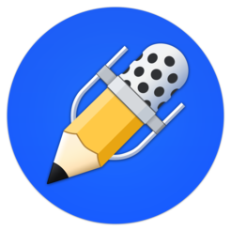 | - Ability to move files, text, photos, GIFs, web pages, and documents from other apps and software.  - Uses iCloud to sync notes between iPad, iPhone, Mac, etc.  - Notes automatically synchronized with audio recordings so that during playback one can listen to what was happening as they wrote.  - Multi-note feature allows two notes side by side.  - Converts handwriting to text.
Cost: $9.99 | Compatibility: iPhone, iPad, iPod touch, Mac

SoundNote
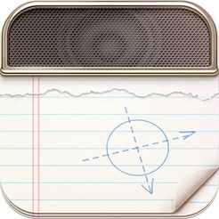 | - Writing/drawing is synchronized with audio recordings.  - Tap on a word and the audio will jump immediately to that point in time.  - Notes and audio recordings can be shared and transferred between devices.
Cost: $4.99 | Compatibility: iPad, Mac

AudioNote
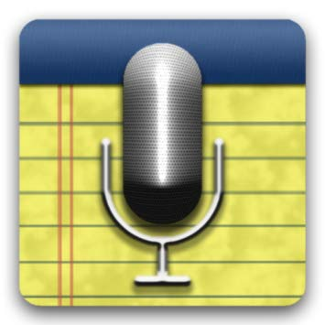 | - Synchronizes notes and audio recordings.  - Each note acts as a link directly to the point when it was recorded.  - Can record and add notes at a later time as well.  - Text, drawings, and photos highlight during recording playback.  - Can import and take notes directly on PDF docs (iPad only).
Cost: $12.99 (AudioNote 2 & Lite are free) | Compatibility: iPhone, iPad, iPod touch

Microsoft OneNote
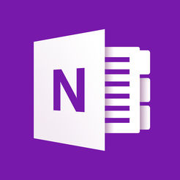 |  | - Create, rename, search, sort and copy pages, sections, and notebooks within the app.  - Ability to pin the pages you use the most.  - Notes synced to the cloud for easy accessibility.  - Converts hand drawn shapes into crisp, regular shapes.  - Record audio notes, insert videos and files.
Cost: Free |  | Compatibility: Windows, iPad, iPhone, Mac, Android
WritePad
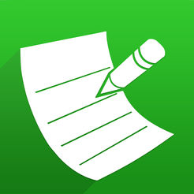 | - Recognizes cursive, print and mixed handwriting styles.  - Write with finger or stylus or use keyboard.  - Shorthand feature offers quick way to insert often-repeated text.  - Allows for exchange of files between devices.  - Built-in spell checker and context analyzer.
Cost: $0.99 (WritePad Professional $4.99) | Compatibility: iPhone, iPad, iPod touch, Android

AccessNote
- Created by American Foundation for the Blind
- However...no longer in app store (discontinued).
- We may want to find another app that is specifically for visually-impaired and blind individuals.
Cost: | Compatibility:

Evernote
- Organize work as searchable notes, notebooks, checklists.
- Create notes in a variety of formats such as text, sketches, photos, screenshots, image files, audio.
- Scan, digitize, and organize paper documents with the camera.
- Syncs automatically across any computer, phone, tablet.
Cost: Free (Premium is $7.99 per month) | Compatibility: iPhone, iPad, iPhone touch, Windows, Android

Penultimate
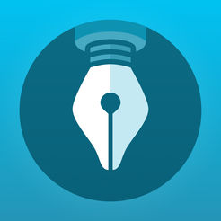 | - Lifelike imitation of pen and paper experience.  - Inking technology creates realistic looking pen strokes and Wrist Protection feature prevents stray marks.  - Choose from different page styles.  - Drift feature allows for page to move along with you to adjust to your pace.  - Sync with Evernote account to access notes from anywhere.
Cost: Free | Compatibility: iPad

PaperPort Notes
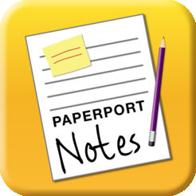 | - Combine documents, web content, audio, typed text and written notes in a single document.  - Voice recognition captures notes through speech.  - Convert scanned documents into editable text.  - Access and share notes through cloud storage.
Cost: Free | Compatibility: iPad

iAnnotate
- Read, annotate, and share PDFs, Microsoft Office files, images, other web content.
- Edits are saved directly on PDFs, so that they can be opened up in external PDF readers.
- Ability to work on two documents side by side.
- Create brand new PDFs.
Cost: $9.99 | Compatibility: iPhone, iPad, iPod touch

Audiotorium
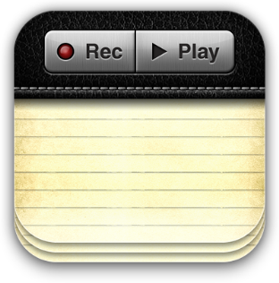 | - Record audio with notes and use audio bookmarks to find important sections of audio later.  - Date, time, common phrases automatically entered with TextExpander feature; can also define own abbreviations.  - Notes backed up in cloud for accessibility and sharing from anywhere.
Cost: unknown | Compatibility: iPad

